**IPO Diagram**

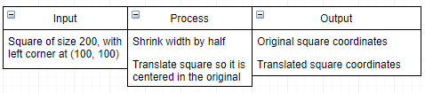

**Pseudocode**

Input rectangle = new rectangle (100, 100, 200, 200)

Print(rectangle coordinates)

Shrink rectangle width (50, 50)

Translate rectangle (20, 20)

Print(modified rectangle)